# Extraction of IPO Data From SDC Platinum

We followed the following steps and filter to construct the sample of US-listed IPOs between 1973 and 2016.

1. Select “Common Stock” in “Global New Issues Database” (Figure 1)
2. Select dates between 01/01/1973 and 12/31/2016 (Figure 2)
   1. The exact number of observations that are filtered out on this stage depends on the list of databases to which this version of SDC is subscribed. The list of databases is mentioned in the line 0 of SDC request (C, CEC, CNC, EC, etc.). Our request resulted in 220,591 observations.
3. Select companies that are listed on US exchanges.
   1. Use “Listing Primary Exchange Nation of Issuer’s Stock” variable to determine the listing exchange
   2. **Important details:**
      1. Sometime SDC has missing values for the exchange variables and sometimes exchange is coded as “unknown”. To capture these exceptions one could use “exclude” filter in SDC rather than “select”. In SDC window press “select all” and mention “exclude” and after deselect the countries that you would want to keep in the sample. (Figure 5)
      2. US is listed in SDC twice: under American and North America regions. To capture all US listing one should deselect both mention of US. (Figure 6)
4. These filters result in 43,816 observations, but the exact number of variables vary with SDC version. (Figure 7)
5. Extract the following variables in SDC request (Figure 8 and attached report)
6. Filing date, Issue date, Issuer, State, Nation, IPO Flag, Original IPO Flag, Offer price, Security, Description, REIT, Unit, Depositary, Deal number, Closed-End Fund, CUSIP, CUSIP9, Proceeds, VC, Gross spread, Manager codes, Tech industry. Low Filing Price, High Filing Price, Amendment History of Low Filing Price, Amendment History of High Filing Price.

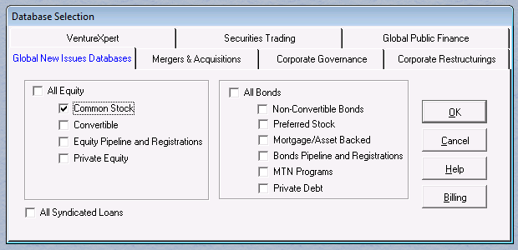

Figure

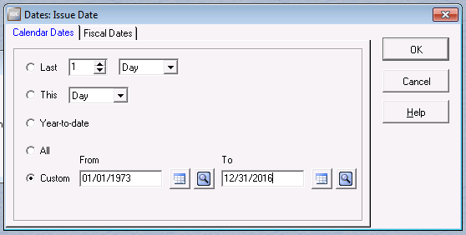

Figure

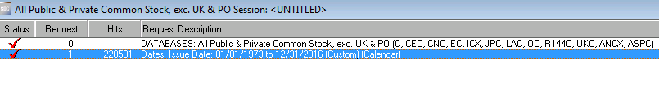

Figure 3

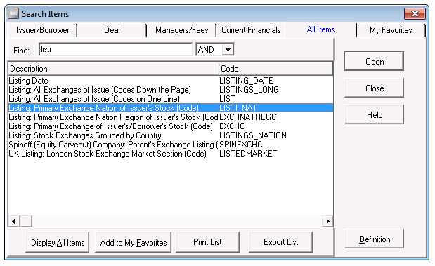

Figure

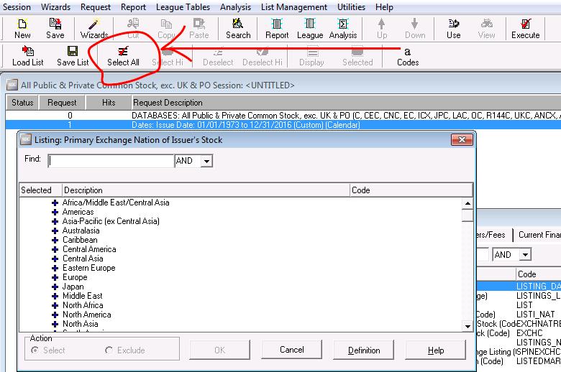

Figure 5

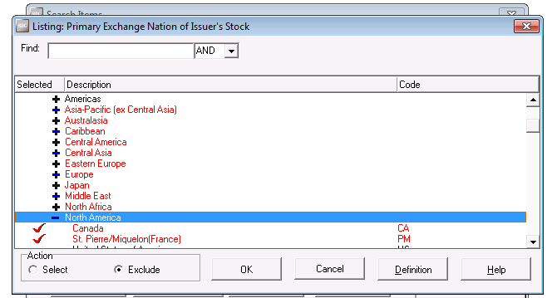

Figure

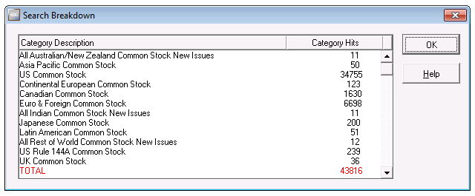

Figure

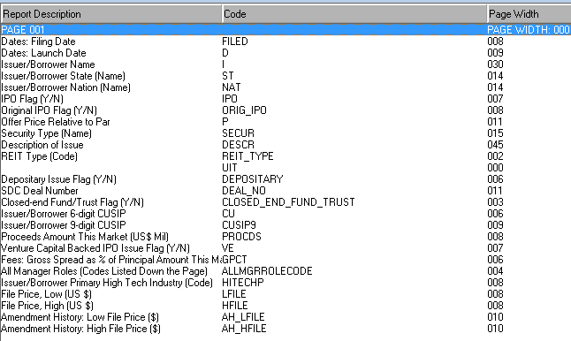

Figure